# *Advanced Topics in Computer Science II (420-G50-HR)*

# *Lab 4 – Introduction to the Sense HAT*

Date due: **February 27, 2025**

**Learning Objectives**

Upon successful completion of this lab exercise, the student will be able to:

* Work with the Sense HAT

Lab Set-Up

1. Ensure you have the Sense HAT installed on your Raspberry Pi.

To Do

**Part A – Treasure Hunt**

In this section, you will use the joystick (*arrow keys on computer keyboard*) and LED Matrix on the Sense HAT to build a memory game. Use the provided starter files in the **part_a** folder. Follow the outlined steps and test each step before proceeding to the next:

1. Display a **yellow coin** at a random location and then hide it. **Hint**: you will need set_pixel(coin_x, coin_y, Y)
2. Create a white pixel to represent the player. The player should be displayed at a random location on the LED Matrix
3. Make the player (white pixel) move using the joystick. You can start by allowing the player to move in the y direction (up and down)

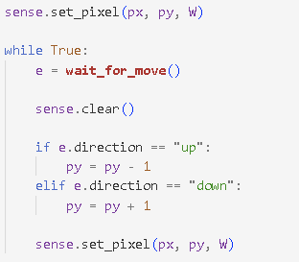

1. Test your code by pressing the up and down arrows on the keyboard. What happens when you reach the top edge and press up?
2. Add a check to ensure the pixel stays on the display
3. Now add movement in the x direction

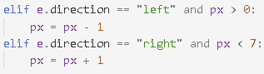

1. Once you have moved to the location where you think the treasure is hidden you need to press the middle button on the joystick. In the emulator you will need to press Enter (Return) on the keyboard. If the player is at the same location as the treasure, then they have found it, and the pixel goes green for 1 second. If the player has picked the wrong location, then the pixel goes red for 1 second.

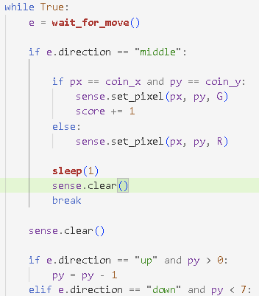

1. Next, let us give the player 5 turns and keep a score. Simply place all the code you have written in a for loop
2. Add a variable called **score** initialized to zero. This will track the player’s score

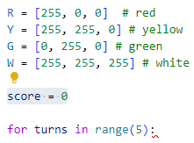

1. Add one to the score when a player chooses the correct location.
2. Display the score using **show_message()**
3. Show a different message depending on how well the player did
4. **Challenge**: You can make the game harder by showing the coin for less time. Alternatively, you can confuse the player by making all the pixels turn yellow before they get to pick the location. Use **sense.clear(Y)** to fill the screen with yellow coins after showing the player where the coin is hidden. You will need **sleep(1)** or however many second you want to show the yellow screen for.

**Part B – Log the Weather**

In this section, you will collect data from the Sense HAT’s sensors and log it to a file. You will then use [PyGal](https://www.pygal.org/en/stable/index.html) module to display the data as a line graph. Use the provided starter files in the **part_b** folder. Follow the outlined steps and test each step before proceeding to the next:

1. You will write the code to collect the temperature data inside **collect.py**. The code should be such that every five seconds the **weather.txt** file is opened, and the current temperature is appended to the file
2. Collect a minimum of 30 temperature readings before stopping the program.
3. In the **display.py** file, write code to read the values from weather.txt into a list called temp
4. Test to ensure that your code reads in the values correctly.
5. Next, add code to create a line graph from the data using Pygal ([refer to the PyGal documentation](https://www.pygal.org/en/stable/index.html))
6. Pygal automatically creates labels for the y axis from the data. Add a title and labels for the x axis. You can number the readings to start from 1 instead of zero as follows:
7. Duplicate steps 1 - 6 into another folder called part_b_humidity. Use your Sense HAT to record humidity instead of temperature.

**Part C – Learn the Alphabets in Reverse**

Using **show_letter** display each letter of the alphabet from Z-A on your Sense HAT.

1. Create a file called part_c.py.
2. Add code such that there is a 1 second pause between each letter display and the other
3. The code should execute continuously

**Part D – SenseHat Humour**

Create a program that randomly picks jokes from a list and displays them on the screen of your Sense HAT emulator.

1. Create a file called part_d.py.
2. The program should continue executing until a KeyboardInterrupt

To submit

When you have completed the lab exercise, call the Teacher’s attention and we’ll go over it together. Then, create a single zip file called *initials*G50L04.zip and copy the file to the Moodle page for the course.